Reverse Words

DESCRIPTION:
Complete the function that accepts a string parameter, and reverses each word in the string. All spaces in the string should be retained.

SOLUTION:
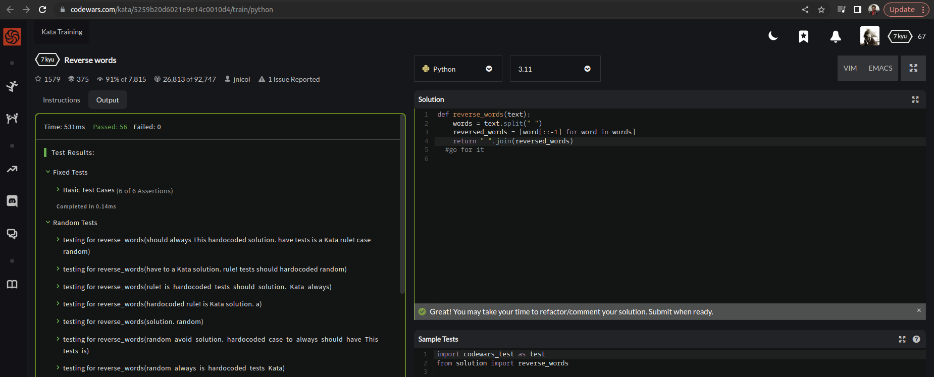

EXPLANATION:
This python function first splits the input string into a list of words using the split method, with the space character as the separator. It then uses a list comprehension to reverse each word in the list by slicing the word from the end to the beginning with a step of -1, using the syntax word[::-1]. Finally, it joins the reversed words back into a string using the join method with a space separator.

